CHANGES HISTORY
PIC | Date | Remarks
BJM.MR | 2018.05.04 | Created
Ghaida | 2018.05.04

TOC
- Parameter Analyst Quarter
- Parameter Analyst Recommendation
- Parameter Oms

Diagram ENTITY RELATIONSHIP

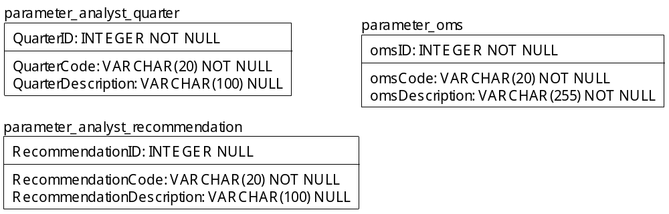

TABLE RELATIONSHIP
No | Table 1 | Table 2 | Type (1:1; 1:N; M:N) | Description

Name |  | parameter_analyst_quarter
Objective
No | Column |  | Type | Rule  (PK, FK, Key, NN, Unik, Index) | Description
1. | QuarterID |  | Integer | NN
2. | QuarterCode |  | Varchar(20) | NN
3. | QuarterDescription |  | Varchar(100) | Null

SAMPLE DATA
No | Column | Sample 1 | Sample 2 | Sample 3 | Sample 4
1. | QuarterID | 1 | 2 | 3 | 4
2. | QuarterCode | Q1 | Q2 | Q3 | Q4
3. | QuarterDescription | First Quarter | Second Quarter | Third Quarter | Fourth Quarter

Name |  | parameter_analyst_recommendation
Objective
No | Column |  | Type | Rule  (PK, FK, Key, NN, Unik, Index) | Description
1. | RecommendationID |  | Integer | Null
2. | RecommendationCode |  | Varchar(20) | NN
3. | RecommendationDescription |  | Varchar(100) | Null

SAMPLE DATA
No | Column | Sample 1 | Sample 2 | Sample 3 | Sample 4
1. | RecommendationID | 1 | 2 | 3
2. | RecommendationCode | OW | UW | N
3. | RecommendationDescription | Over weight | Under weight | Neutral

Name |  | parameter_oms
Objective
No | Column |  | Type | Rule  (PK, FK, Key, NN, Unik, Index) | Description
1. | omsID |  | Integer | NN
2. | omsCode |  | Varchar(20) | NN
3. | omsDescription |  | Varchar(255) | NN

SAMPLE DATA
No | Column | Sample 1 | Sample 2 | Sample 3 | Sample 4
1. | omsID | 1
2. | omsCode | oms.simpi-pro
3. | omsDescription | OMTS SIMPI PRO

